STEP-1: create three branch in git

1-create a new git repository.

2-create three branches( master.dev.qa)

STEP-2: create three Jenkins jobs

1-log in to Jenkins

2- create three new Jenkins job

Job-1: httpd-master

Job-2: httpd-dev

Job-3: httpd-qa

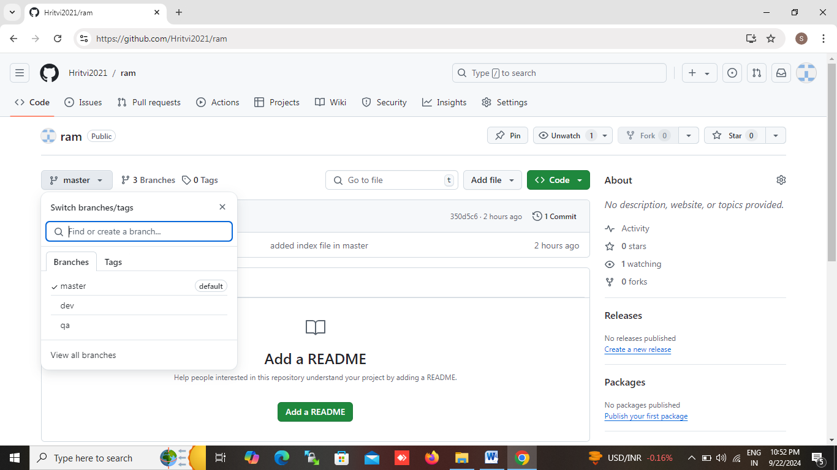

STEP-3: go to httpd-master(job-1)

1- configer the job:

-source code management:Git

-repository URL: repo url (we created repo on git hub,give the credentials ssh key username/password for private repo)

-add branch name(master)

2- add build step:

-execute shell command:

Sudo yum install httpd –y && sudo service httpd start

3- save and trigger the job

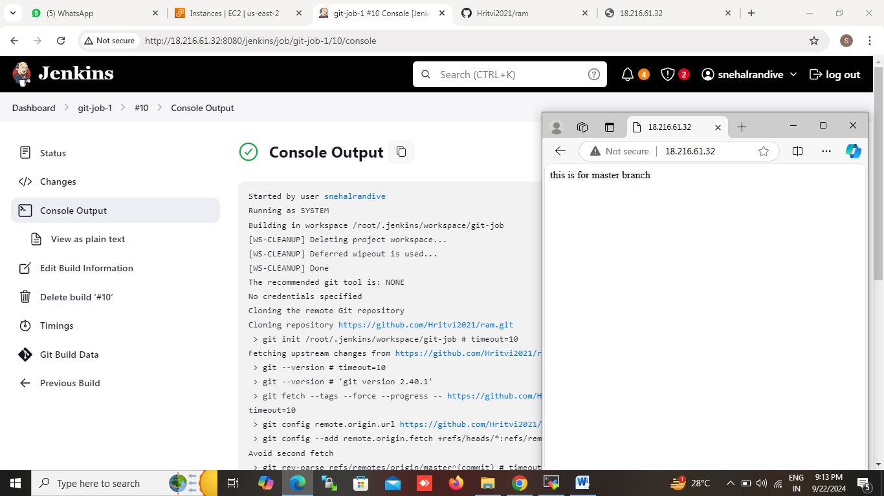

STEP-4: go to httpd-dev (job-2)

1-configer the job:

-source code management: Git

-repository URL: repo url (we created repo on git hub give the credentials select ssh key username/password for private repo)

-add branch name(dev)

2-add build step:

-execute shell command:

Sudo yum install httpd –y && sudo service httpd start

3-save and trigger the job

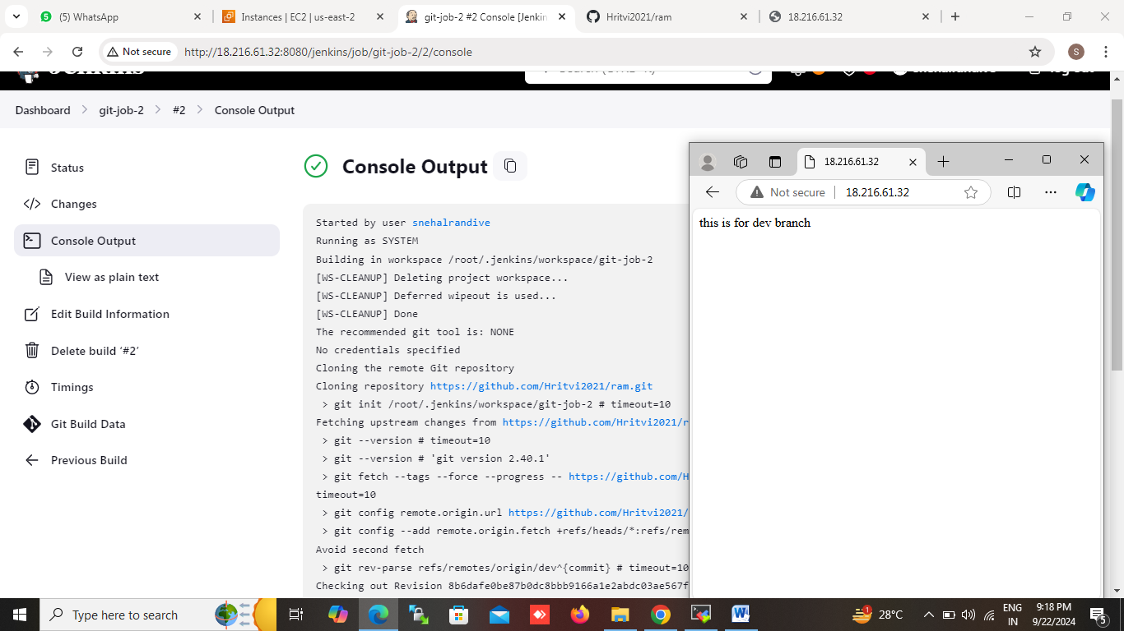

STEP-5: go to httpd-qa (job-3)

1-Configer the job:

-source code management: Git

-repository URL: url ( we created repo on git hub give the credentials select ssh key username/password for private repo)

-add branch name (qa)

2 -add build step:

-execute shell command:

Sudo yum install httpd –y && sudo service httpd start

3-save and trigger the job

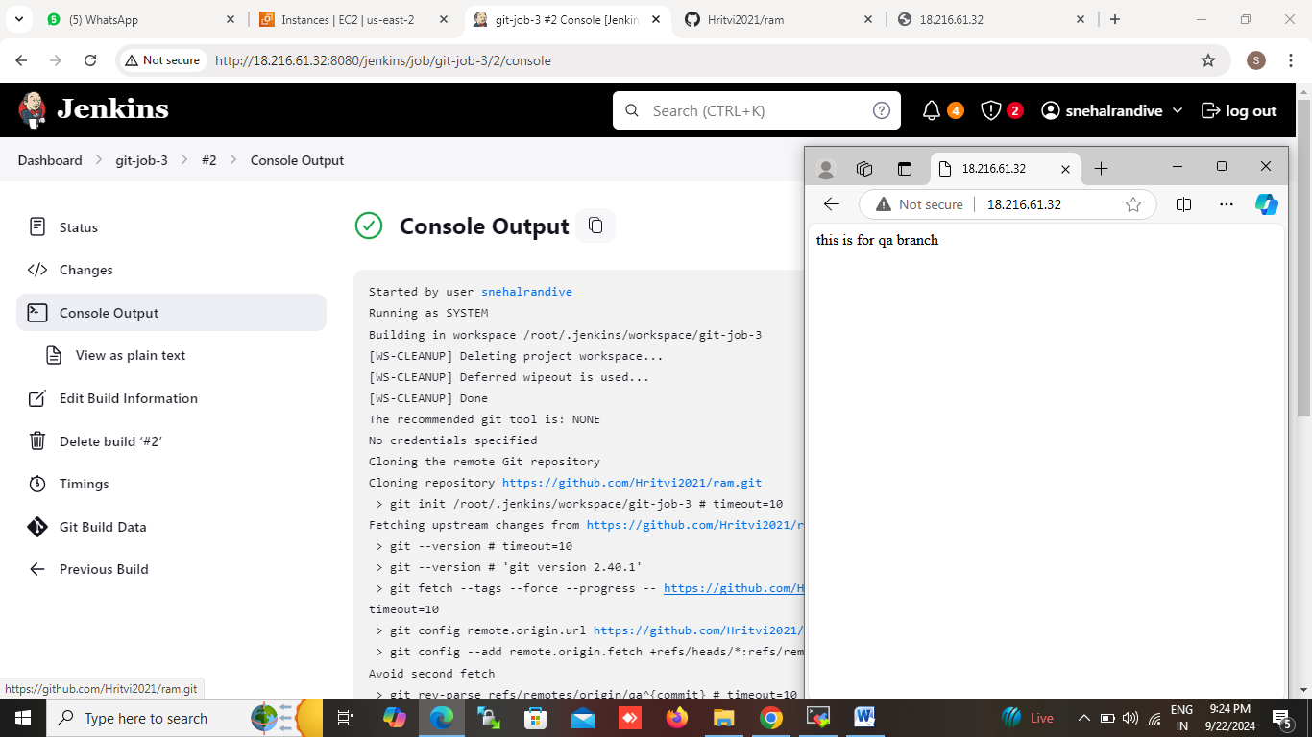

Jenkins file (using pipeline based job)

Pipeline{

agent any

stages{

stage (‘build and deploy’){

steps{

git url:’ git@repo url link’,credentialsid:’username-password’,branch:’master’

sh ‘sudo yum install httpd –y && sudo service httpd start’

}

}

}

}

Pipeline{

agent any

stages{

stage(‘build and deploy’){

steps{

git url: ‘ git@repo url link’,credentialsid:’username-password’,branch:’dev’

sh ‘sudo yum install httpd –y && sudo service httpd start

}

}

}

}

Pipeline{

agent any

stages{

stage(‘build and deploy’){

steps{

git url: ‘ git@repo url link’,credentialsid:’username-password’,branch:’qa’

sh ‘sudo yum install httpd –y && sudo service httpd start

}

}

}

}